# Introduction to Selenium:

1. **Write down a steps and process of Selenium IDE Installationon any 1 browser (eg.Firefox).**

Installation in Goolge Chrome:

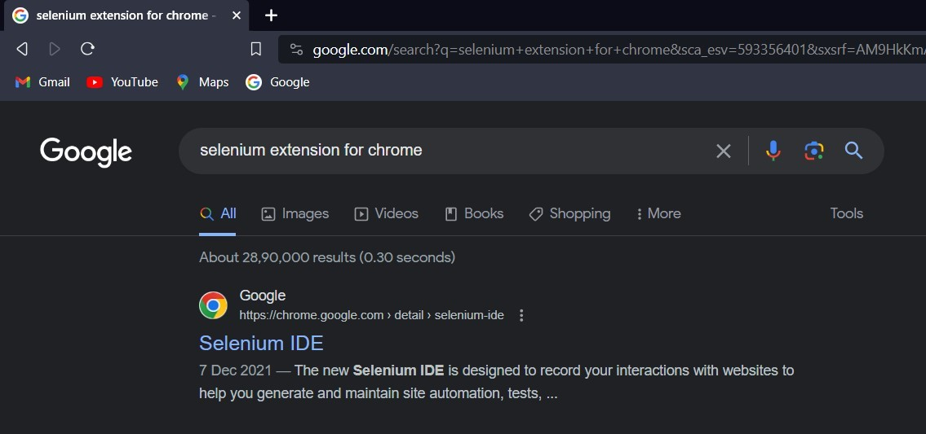Step1: Search on Google chrome for “selenium extension for chrome”

Step 2: click on add to chrome:

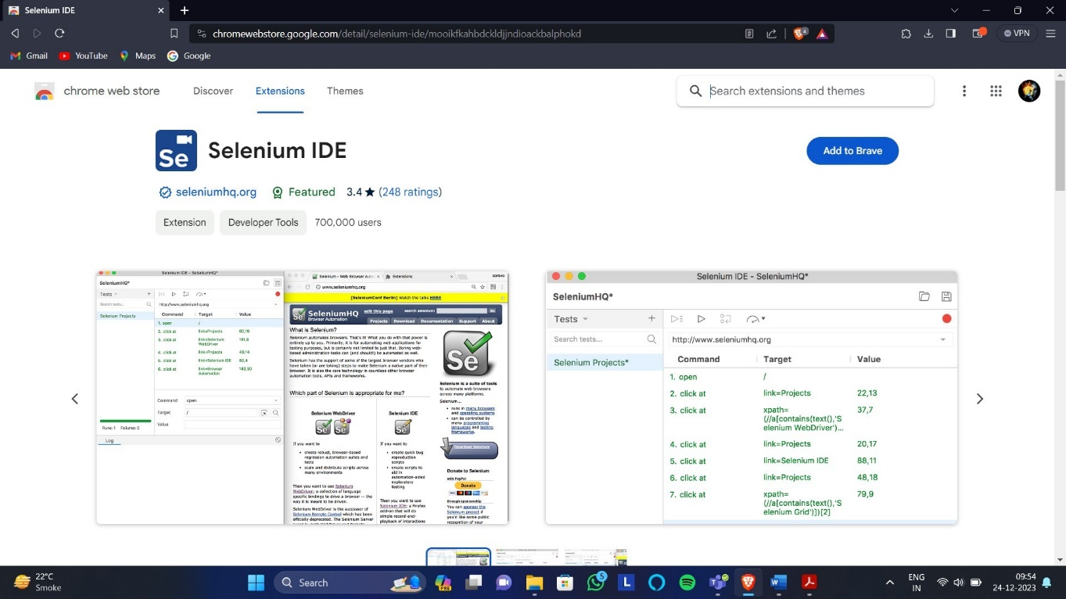

Step : Click on Add to Chrome

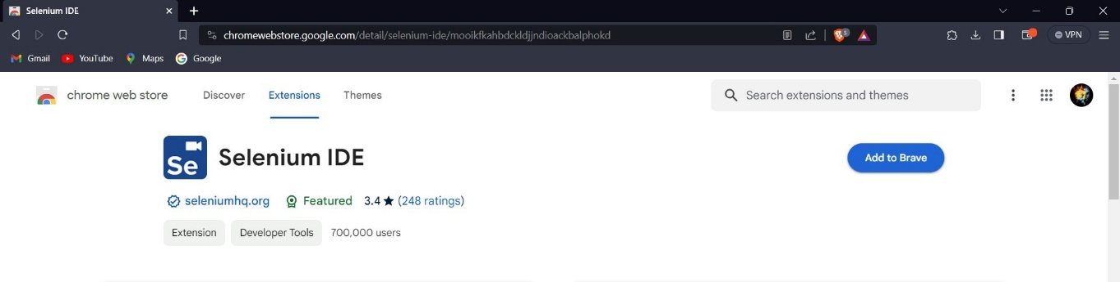

Step 4: Click on Add Extension

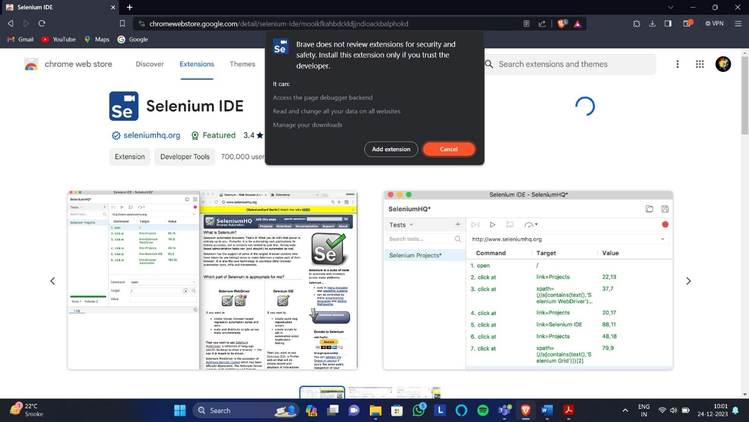

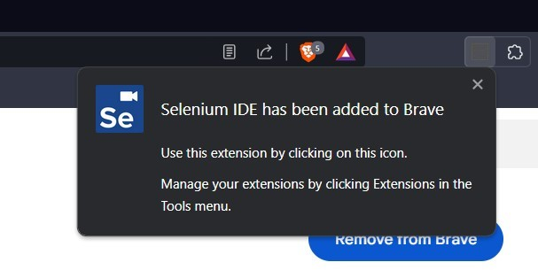Step 5: Installation Done and the following pop-up will be shown

Step 6: To open Selenium in Chrome, Click on Following

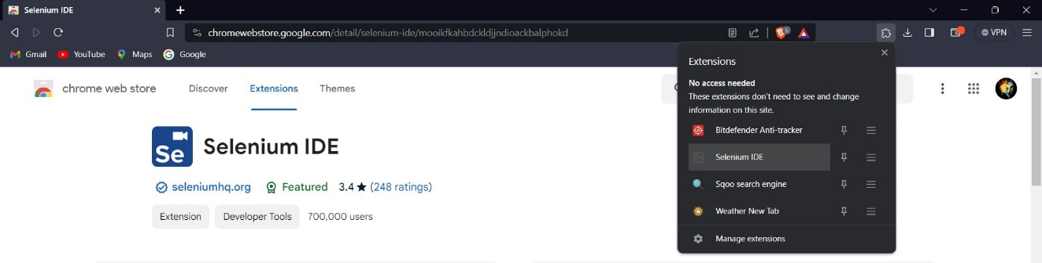

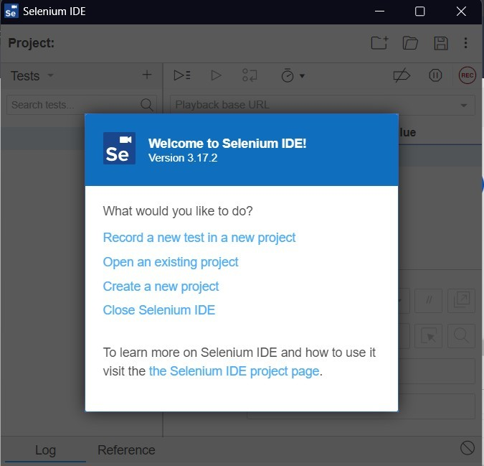Step 7: Selenium Window will open

# Record and run test cases on demotour website for login pagethrough Mozila Firefox.

Case1: Both username and password are incorrect

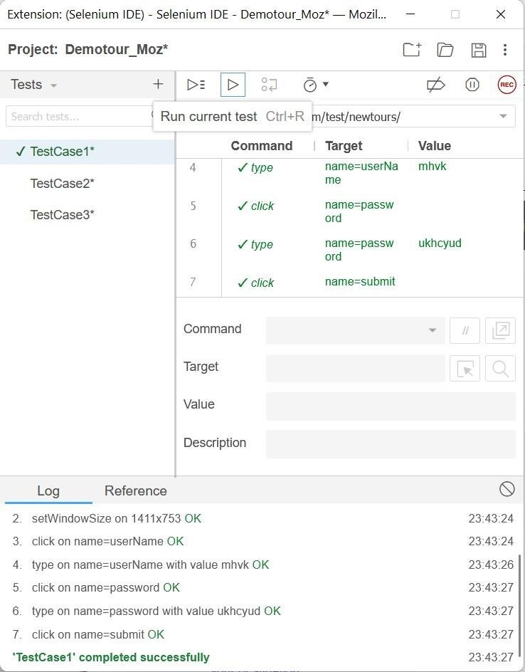

Case2: Username is correct but password is incorrect

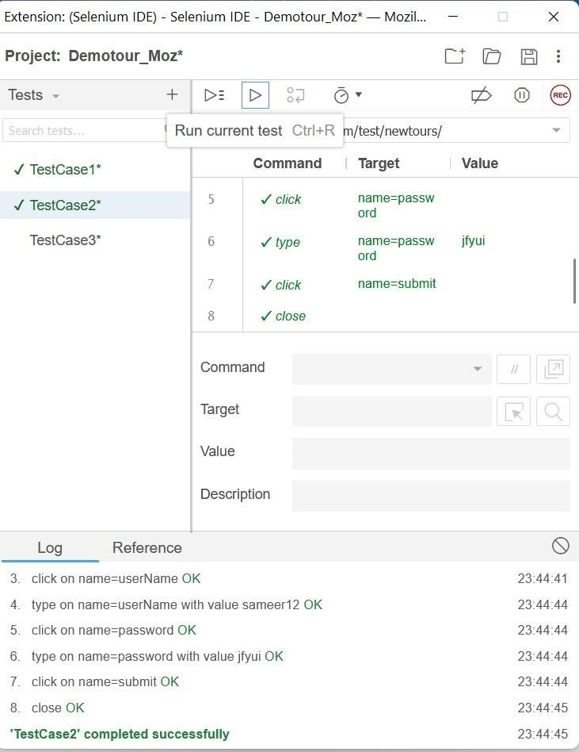

Case3: Username is incorrect but password is correct

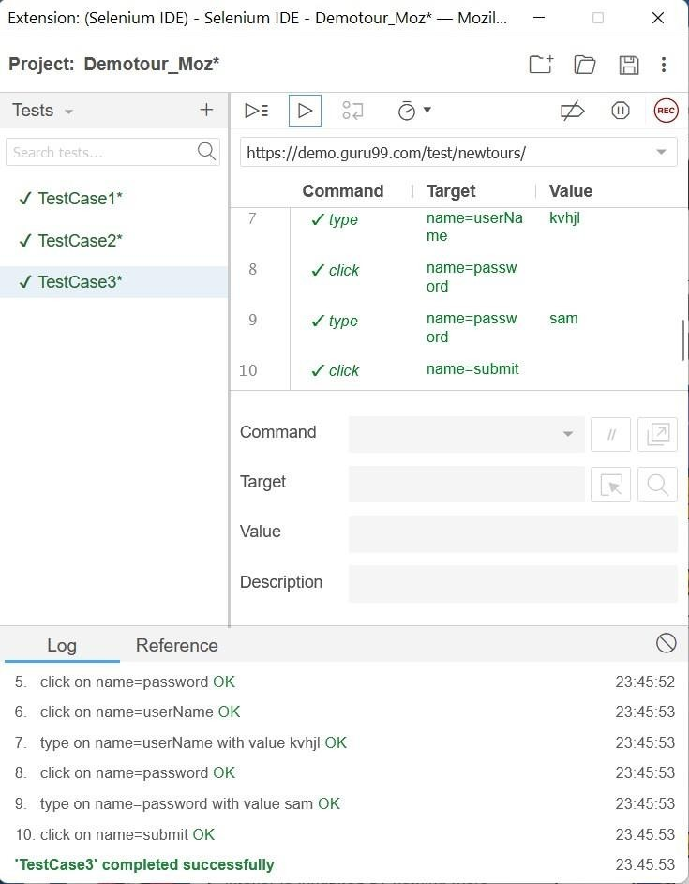

Case 4: Both Username and Password are correct

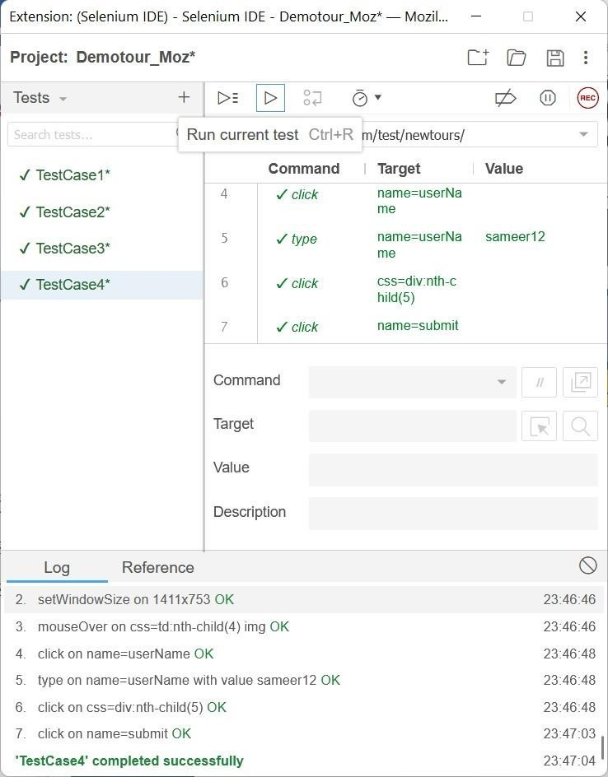

# Record and run test cases on demotour website for login pagethrough Google Chrome.

Step 1: Click on new Project and give the project name

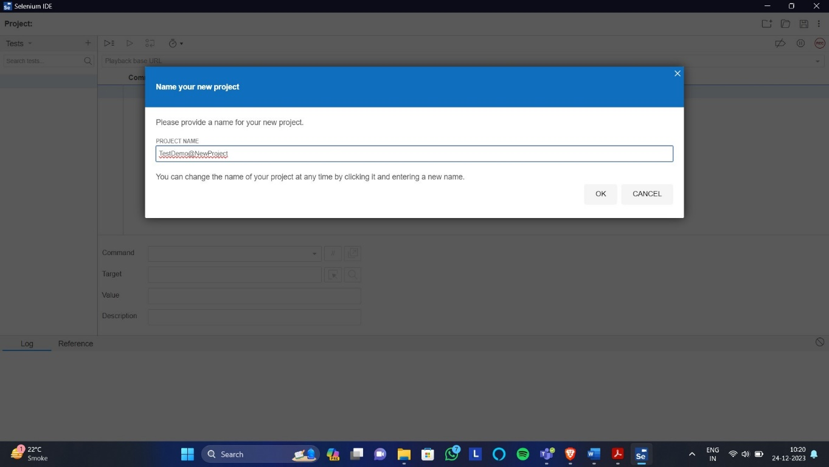

Step 2: Paste the demotour website Link(https://demo.guru99.com/test/newtours/) as Shown and Click on Rec

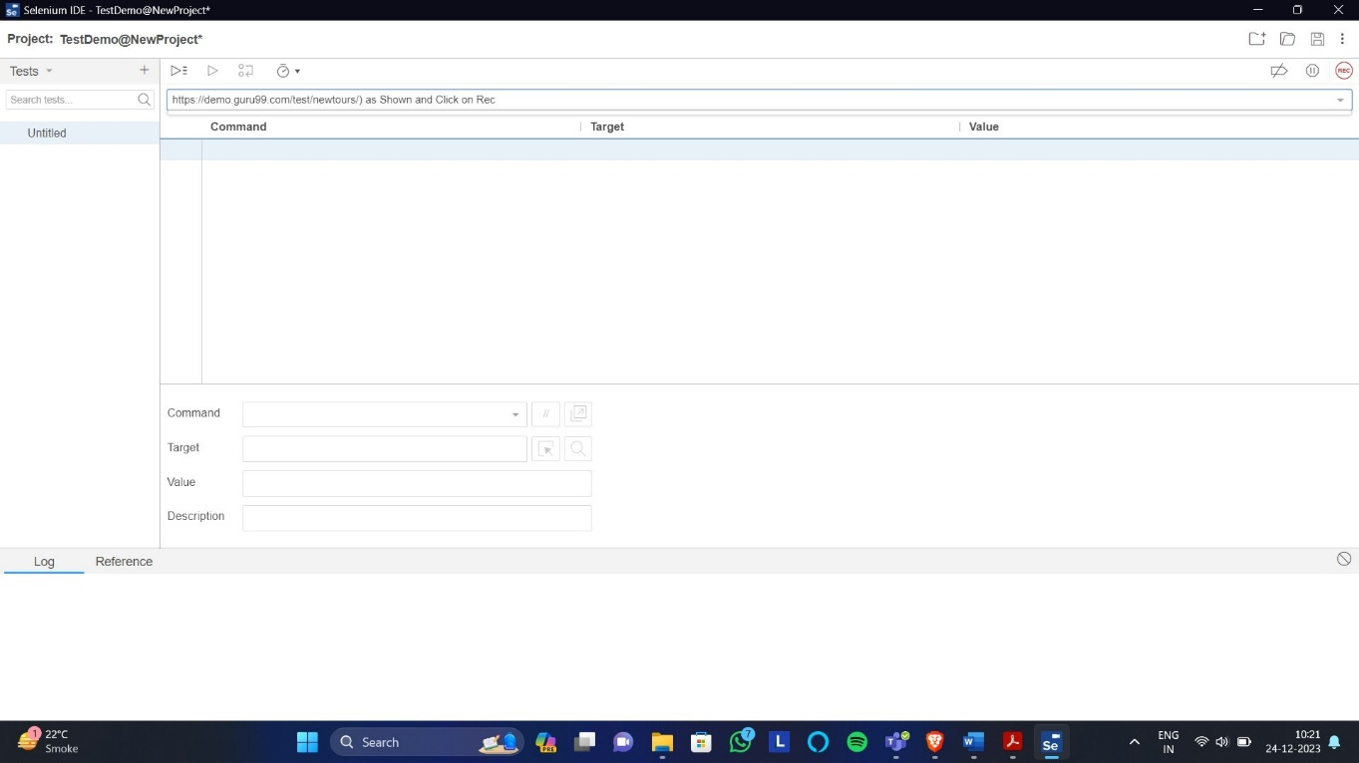

Step 3: New window will open maximise that window

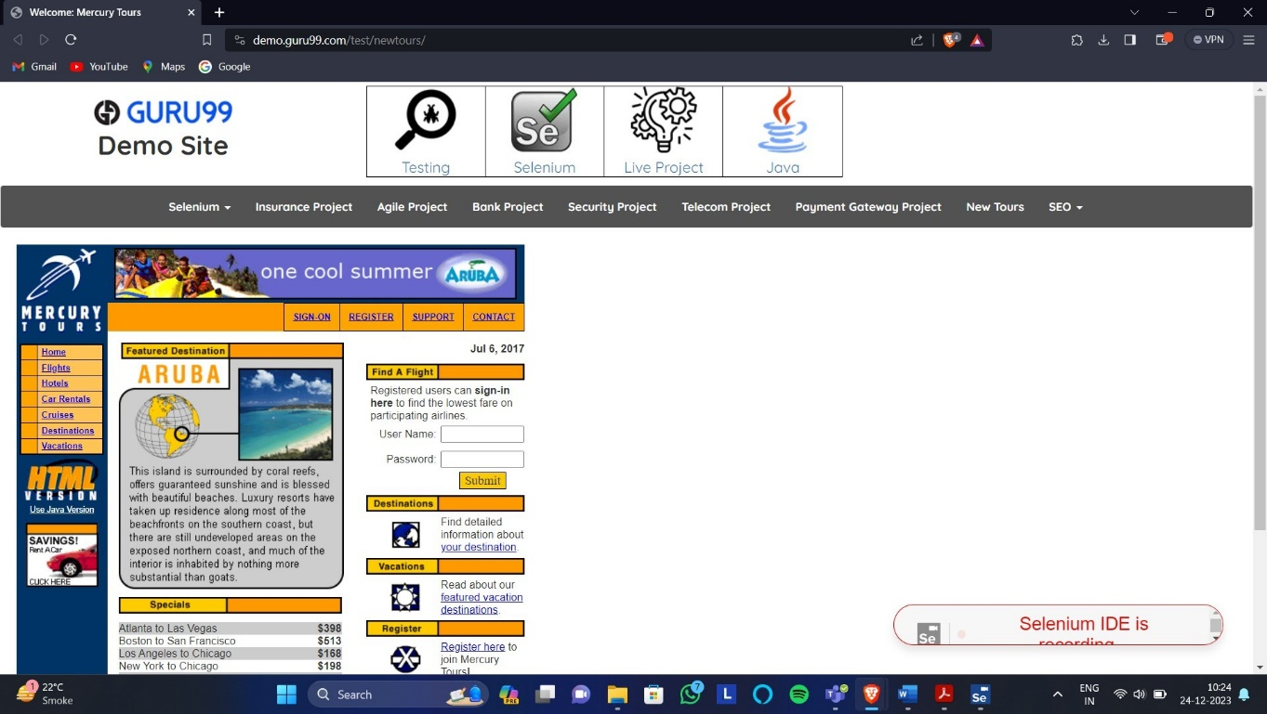

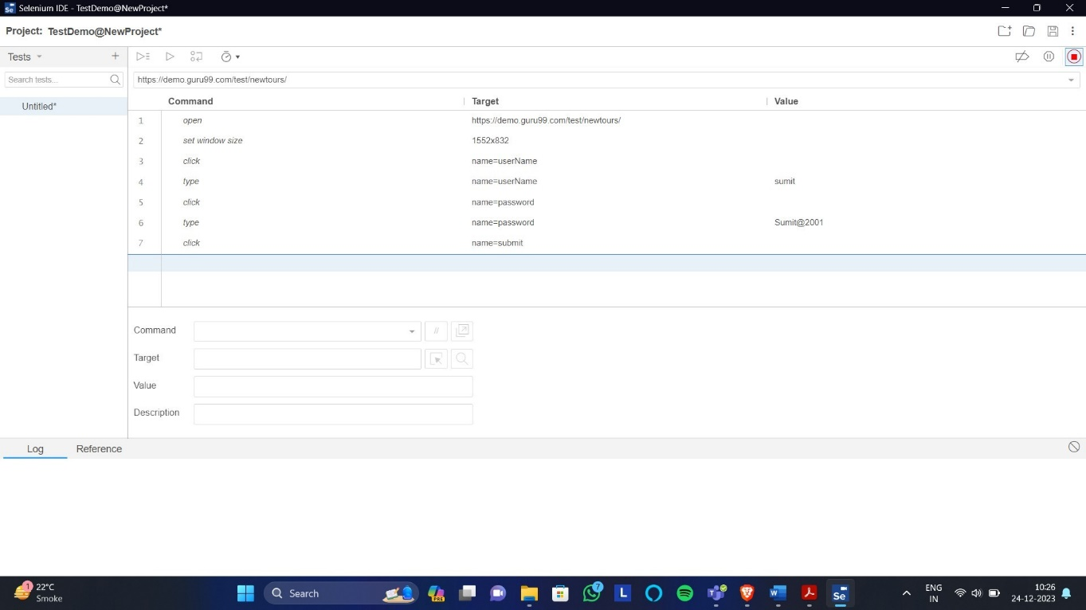First Test Case: Both the username and password is incorrect

Second Test Case: Username is correct but Password is incorrect

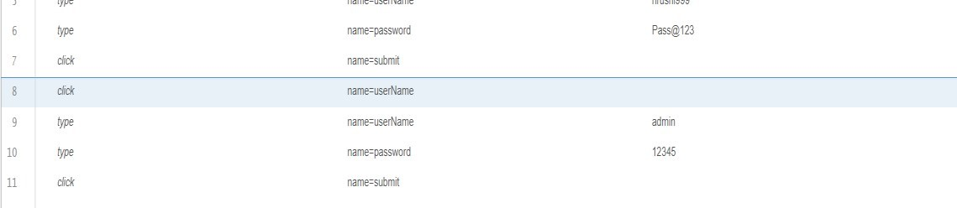

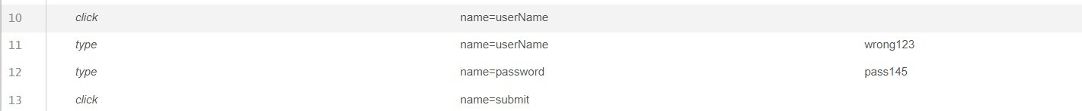Third test Case: Username is incorrect but Password is correct

Fourth Test Case: Both Username and password is Correct

# Record and run test cases on Registration form of any website

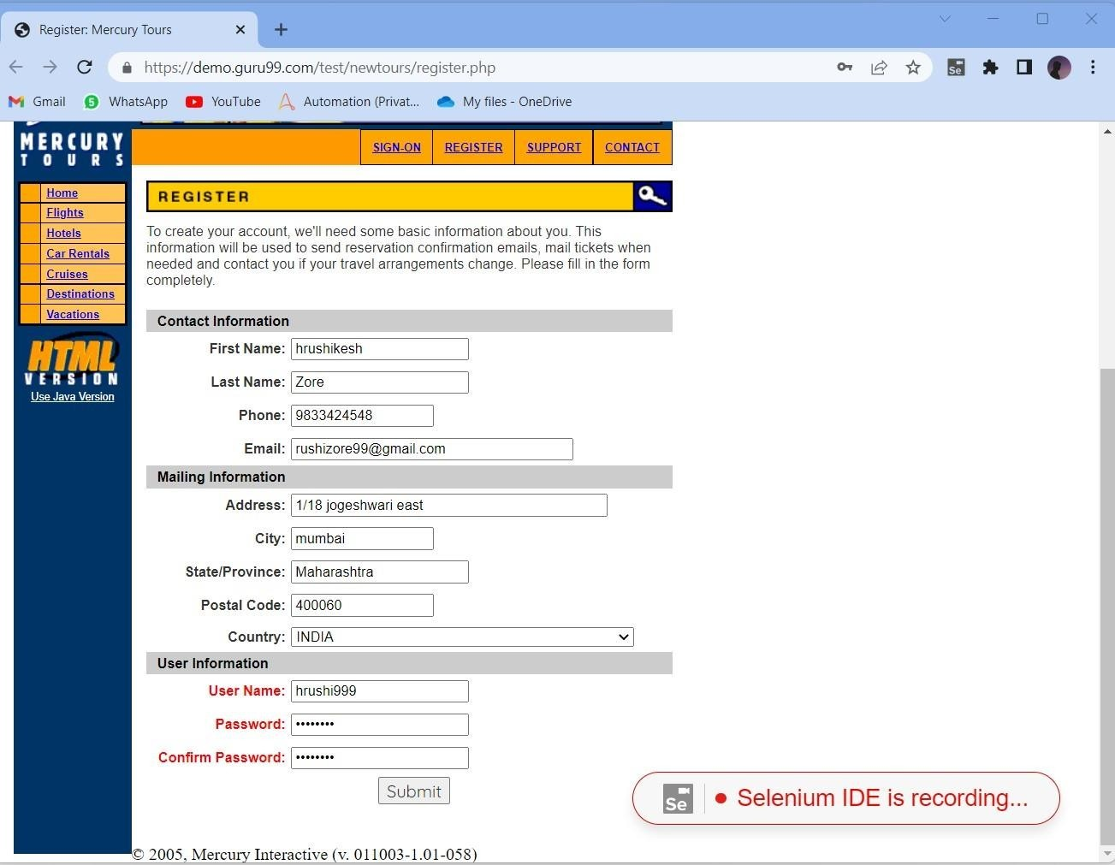

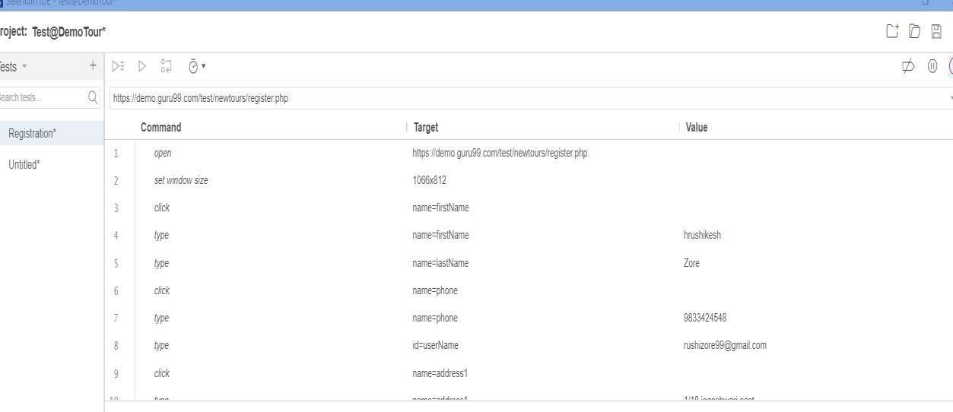

1. **Record and run test cases on any website to check thevalidations of elements. (eg. IRCTC,**

# MSRTC, etc):

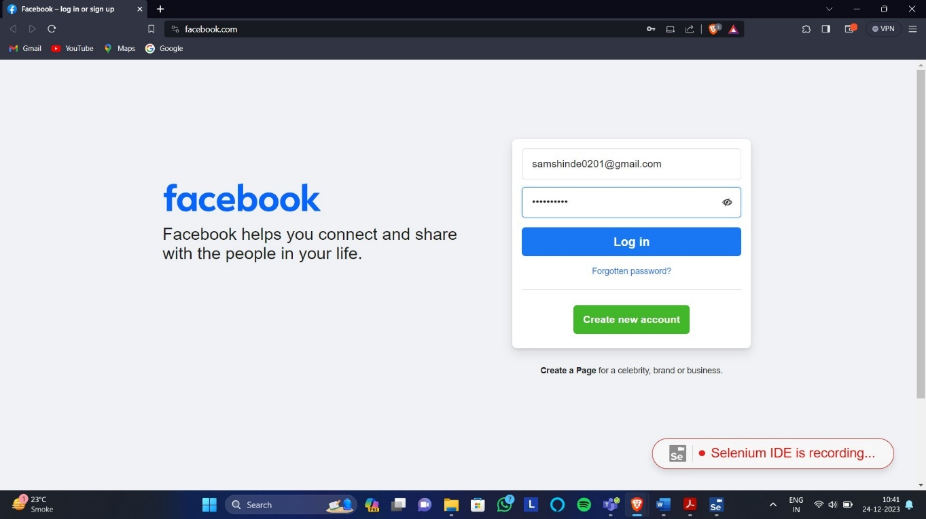TestCase1: facebook Username and password incorrect

TestCase2: Gmail

